# Database Systems Lab Manual (Lab 0)



Session: Fall 2024

## LAB INSTRUCTOR: AYESHA MAJID ALI

**Objective:**

**1. Installation of Oracle 10G Equipment Requirements:**

Oracle 10 G

**How to Install Oracle 10 G for Windows?**

Installation Oracle 10 G for Windows.

Follow the below steps to install Oracle 10G on windows:

**Step 1**: Open the software file shared with you or download it from the drive first and then open it. (drive link)

The following pop up will appear after you open the file.

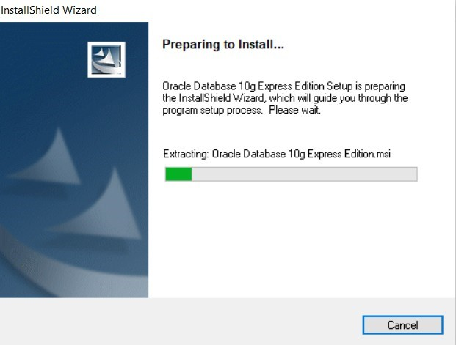

**Step 2:** Click on next.

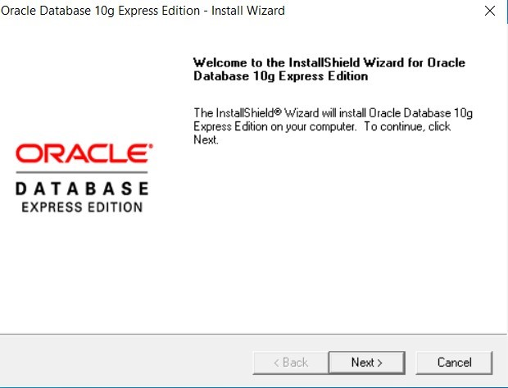

**Step 3:** Click on I accept.

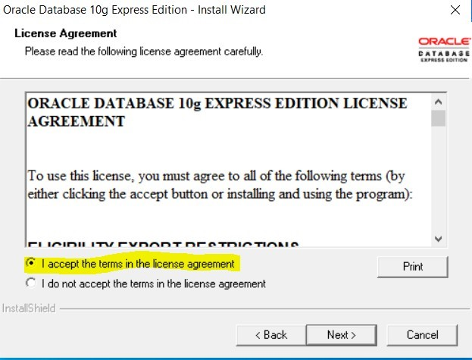

**Step 4:** Click on next.

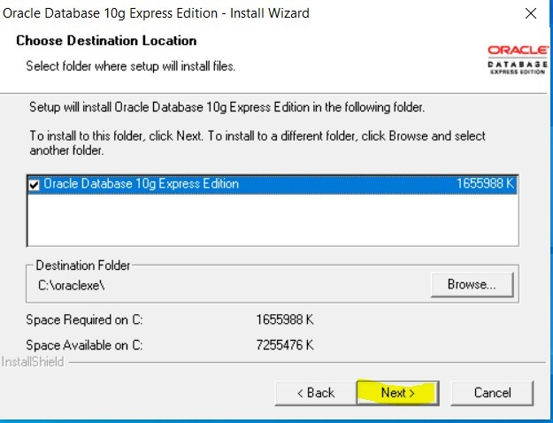

**Step 5:** Click on next.

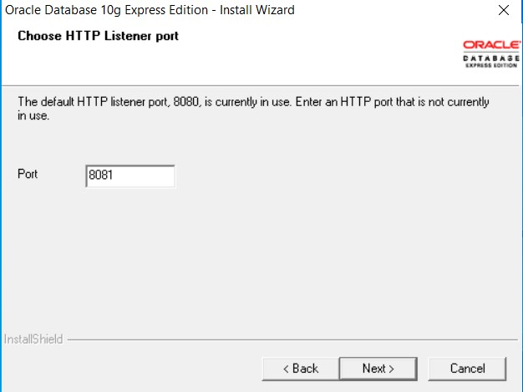

**Step 6:** Enter the password 1234 and click on next.

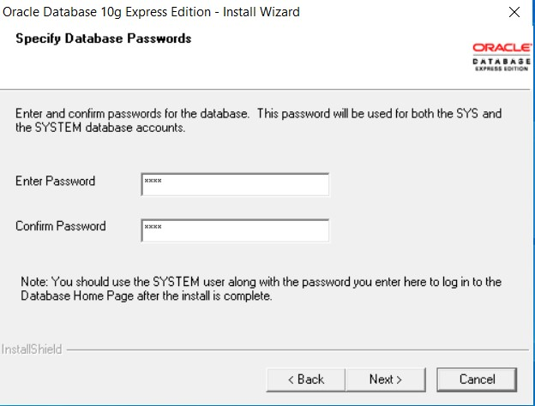

**Step 7:** Click on install.

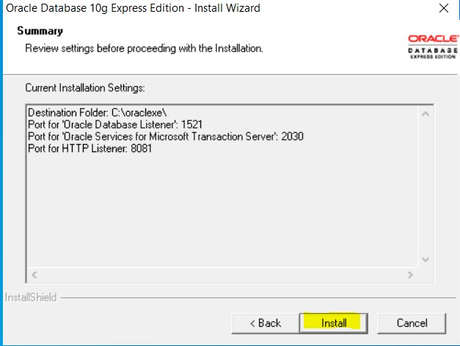

**Step 8:** Installation will begin.

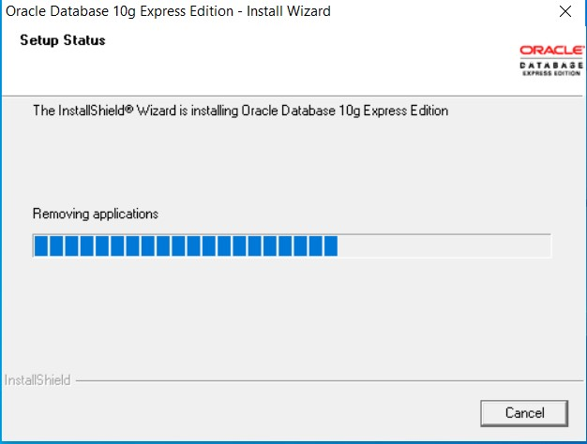

**Step 9:** Click on finish.

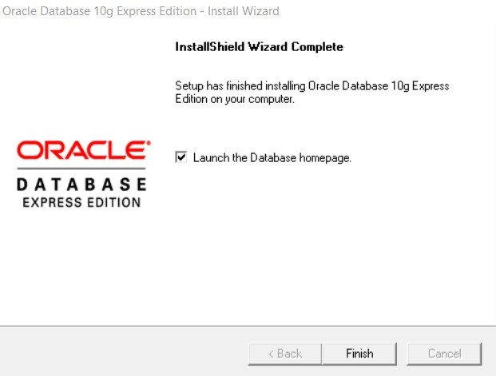

**Step 10:** Type “system” as username and password “1234” as we have set above.

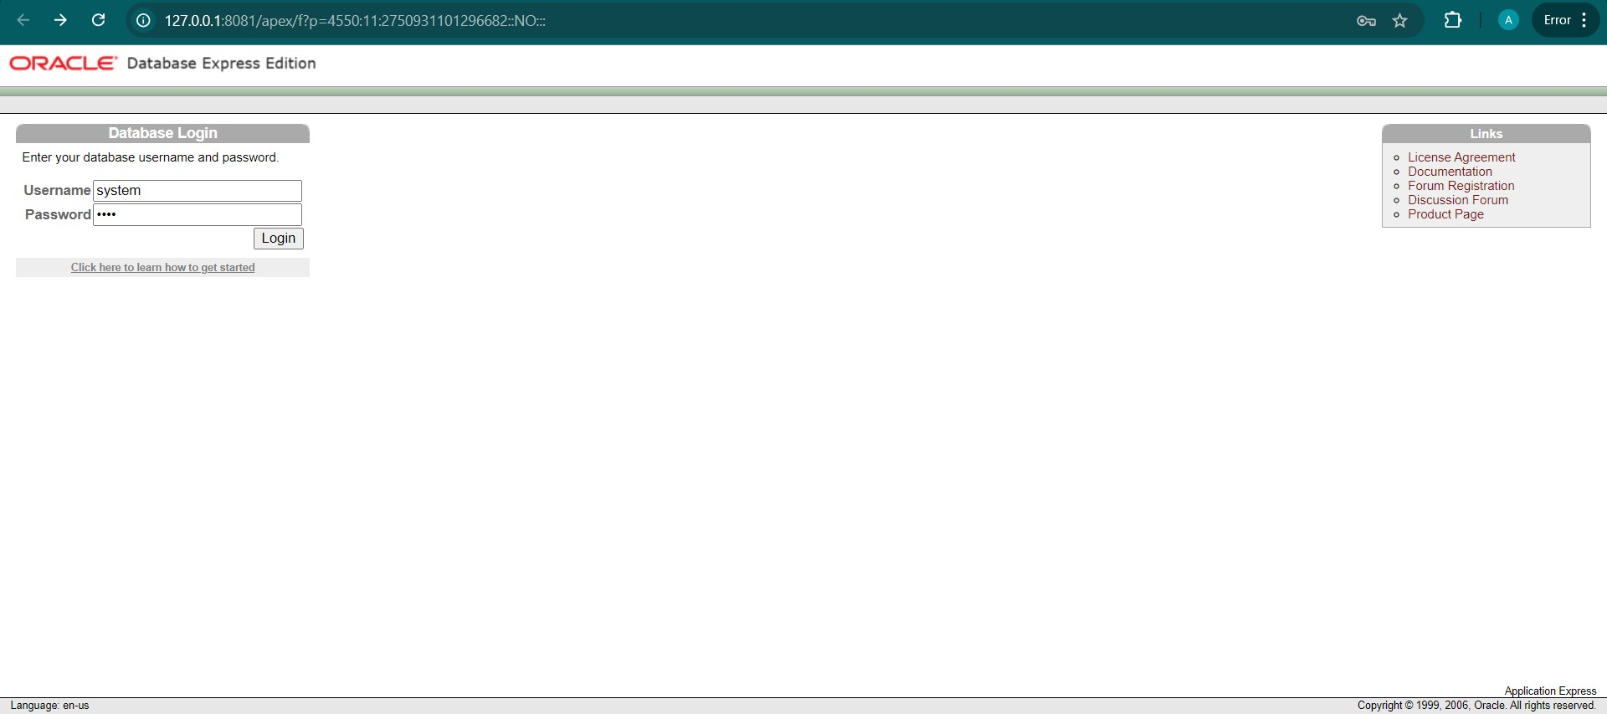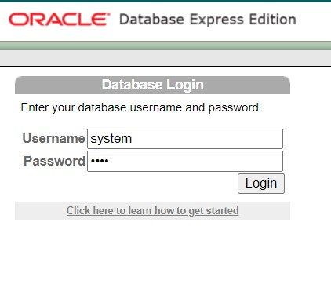

**Step 11:**  You will be directed towards the following web page.

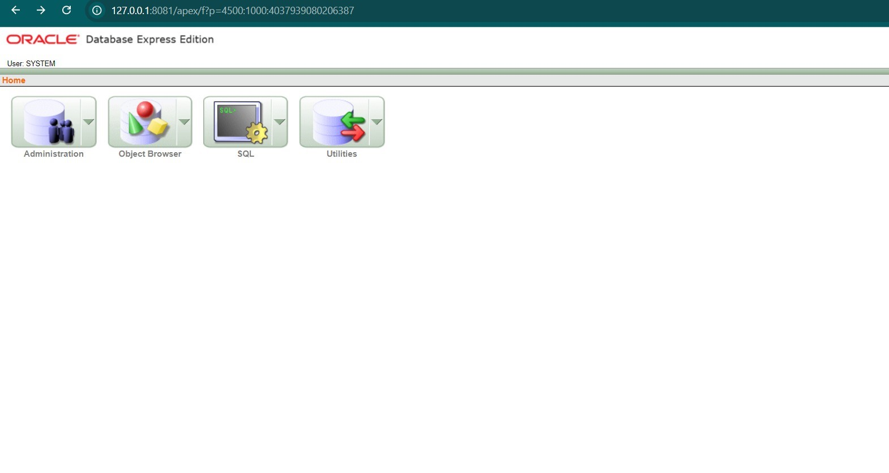

**Lab Task:** Install Oracle 10 G within your system (PC/Laptop).